**CHAPTER FOUR**

**SYSTEM IMPLEMENTATION, RESULTS AND DISCUSSION**

4.1 Introduction

This chapter presents the implementation, results, and discussion of the University of Ilorin Computer-Based Test (CBT) Portal with Facial Recognition. The system was designed to provide a secure, efficient, and user-friendly platform for conducting computer-based examinations, leveraging facial recognition for authentication. The following sections detail the system’s architecture, modules, testing, security, usability, and key findings.

**4.2 System Design and Implementation Overview**

4.2.1 System Architecture

The system is structured as a modular web application, with clear separation between user and admin functionalities. The architecture consists of:

1. Frontend: Built with Streamlit for rapid UI development and real-time interactivity.
2. Backend: Handles facial recognition, user management, exam logic, and data storage.
3. Data Storage: Uses JSON and TXT files for questions, results, logs, and user images.

4.2.2 Tools and Technologies Used

1. Python: Core programming language.
2. Streamlit: For web interface and user interaction.
3. OpenCV, facenet-pytorch, torch: For facial detection and recognition.
4. Pandas, matplotlib: For data analysis and visualization in the admin dashboard.
5. FPDF: For generating PDF reports.
6. Other Libraries: Pillow (image processing), numpy (numerical operations), flask (optional for future API integration).

4.2.3 Facial Recognition Workflow

* 1. Enrollment: Users register by capturing their facial image via webcam. The system extracts and stores facial embeddings.
  2. Authentication: During login, a new facial image is captured and compared to the stored embedding using cosine similarity. Only a match above a set threshold grants access to the exam.
  3. Security: All facial data is stored securely, and authentication logs are maintained for audit purposes.

4.3 System Modules and Interface

4.3.1 Enrollment Module

The enrollment module allows new users (students) to register by capturing their face using a webcam. The system saves the facial image and computes an embedding for future authentication. This module ensures that only unique usernames are accepted and that the captured image is clear and suitable for recognition.

Features:

* + Webcam-based face capture for registration.
  + Real-time feedback on image quality.
  + Prevention of duplicate usernames.
  + Secure storage of user images and embeddings.

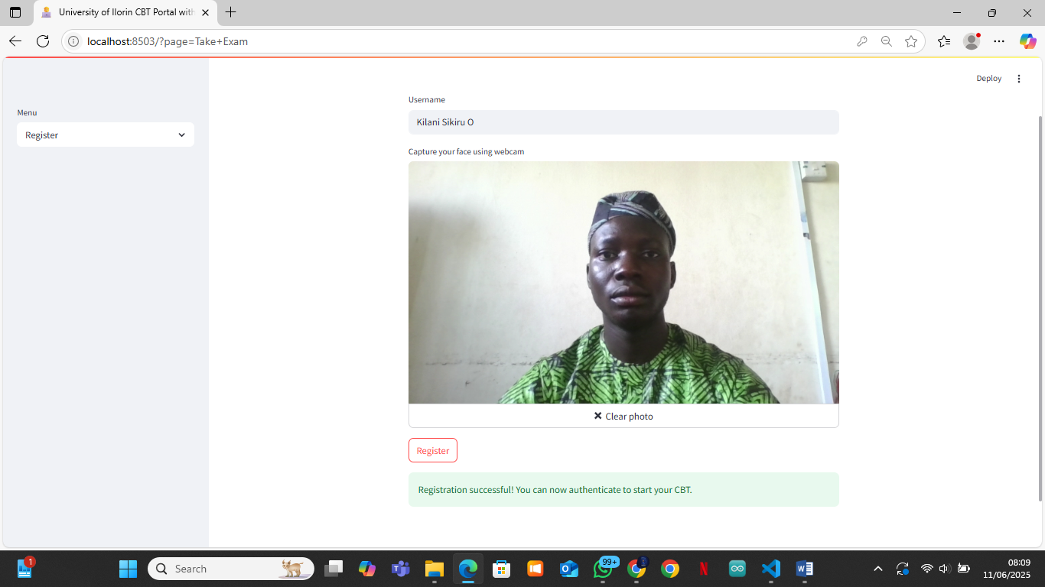

Figure 4.1: Registration Page – User capturing face for enrollment

4.3.2 Authentication Module

The authentication module is responsible for verifying the identity of users before granting access to the CBT. It captures a live facial image, compares it to the stored embedding, and logs the attempt. Only users whose live image matches the stored template are allowed to proceed to the exam.

Features:

* + Webcam-based live face capture for login.
  + Real-time facial recognition and matching.
  + Immediate feedback on authentication success or failure.
  + Logging of all authentication attempts for security auditing.

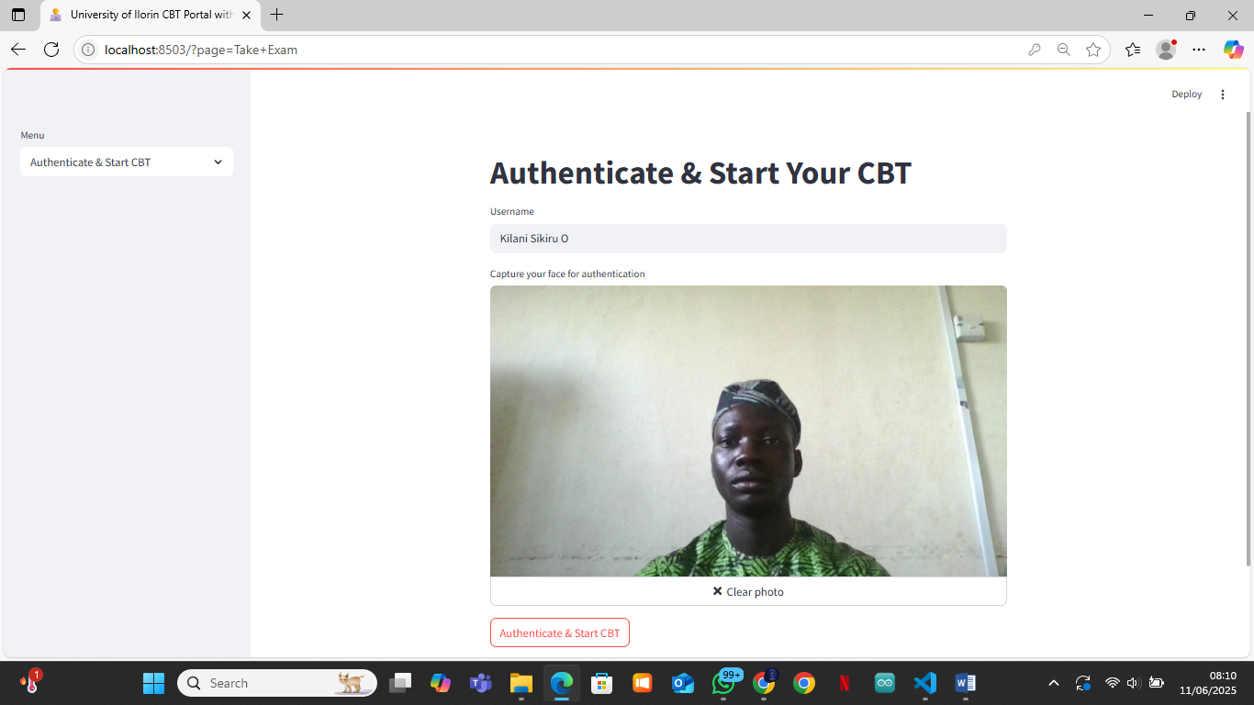

Figure 4.2: Authentication Page – User authenticating with webcam

4.3.3 Admin Module

The Admin Dashboard is a comprehensive control panel for managing the CBT platform. It is organized into several tabs, each providing specific management and reporting functions:

A. Analytics Tab

* + Visualizes authentication attempts and outcomes with charts.
  + Displays bar charts for authentication success/failure and per-user statistics.
  + Helps the admin monitor system usage and detect suspicious activity.

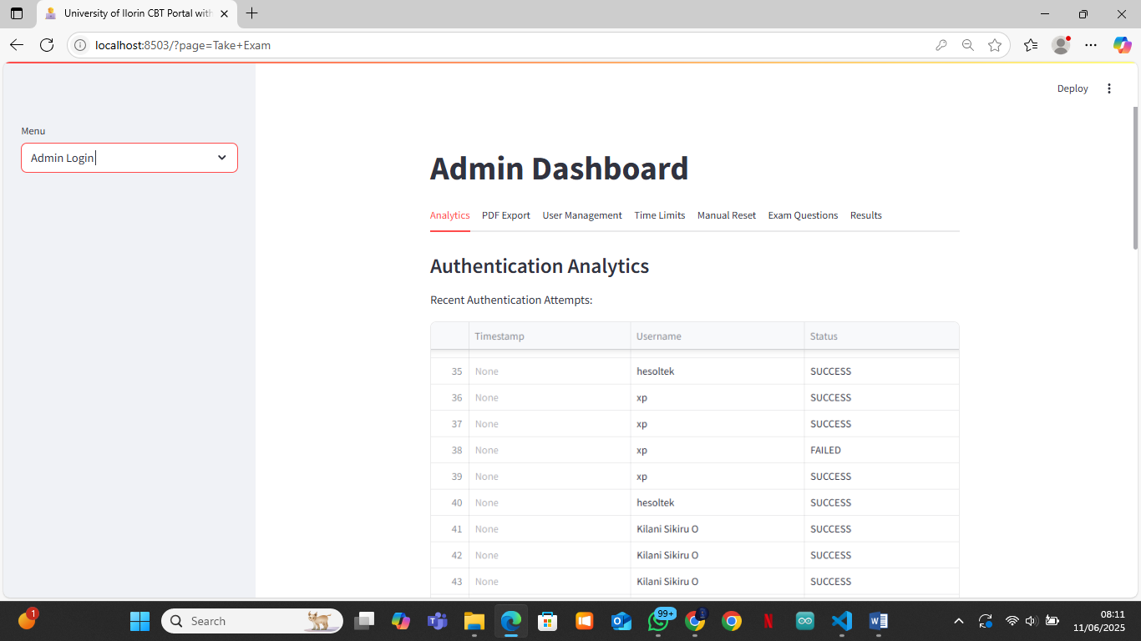

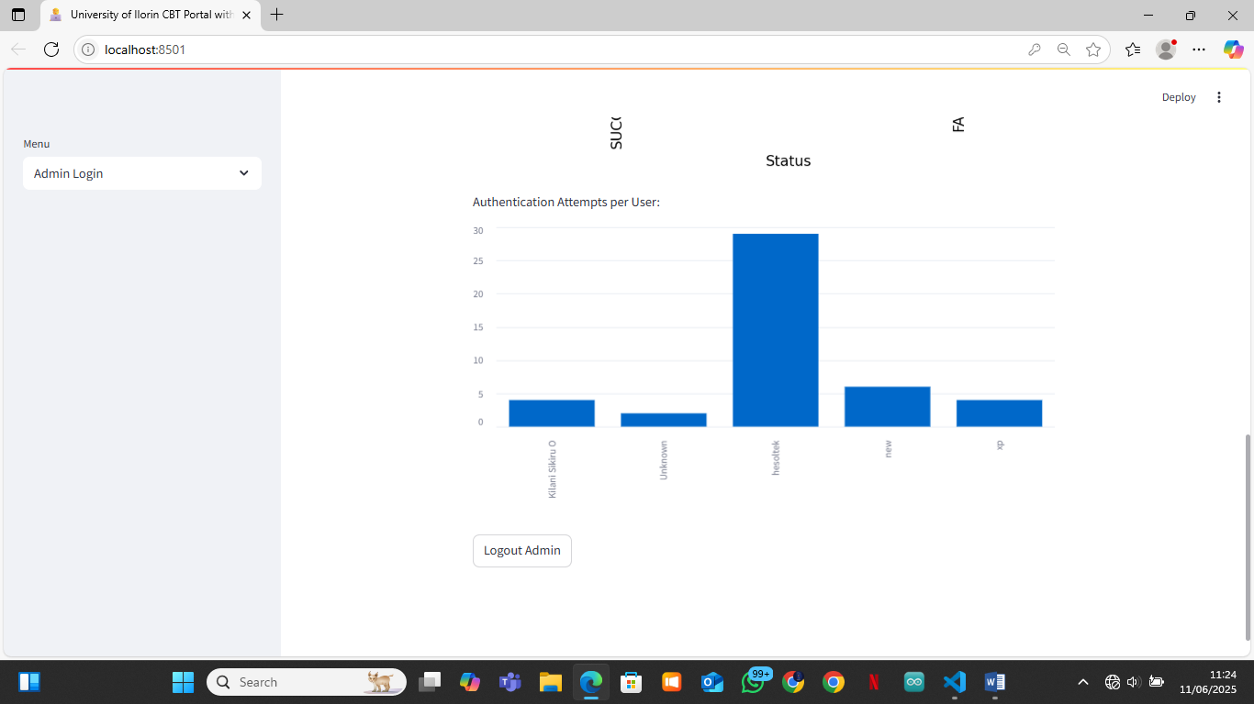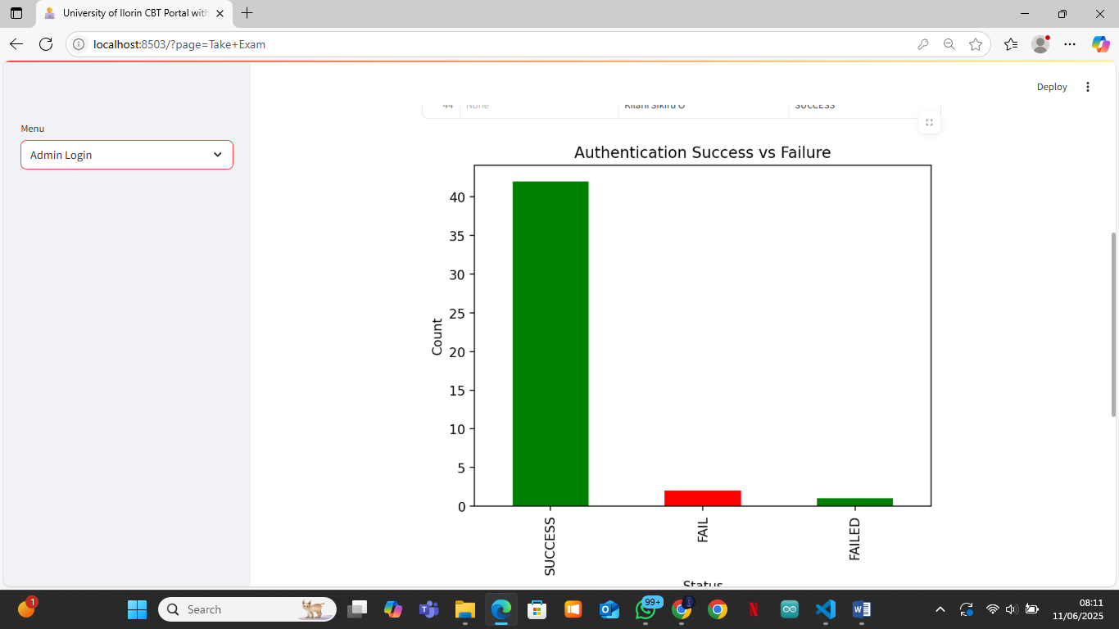

Figure 4.3: Admin Dashboard – Analytics Tab

B. PDF Export Tab

* + Allows exporting of authentication logs and CBT results as PDF files for record-keeping.
  + Enables easy sharing and archiving of exam data.

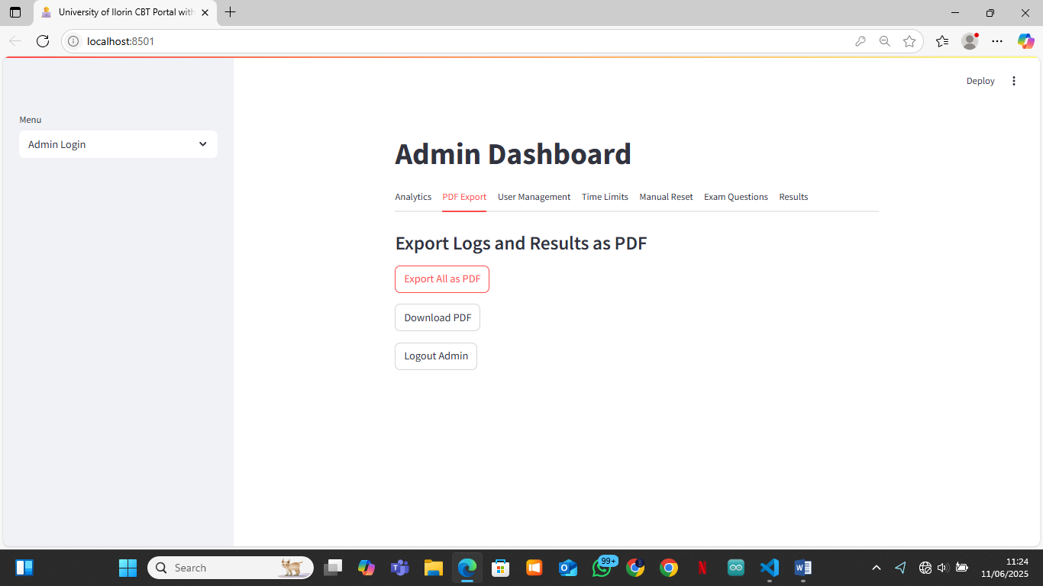Figure 4.4: Admin Dashboard – PDF Export Tab

C. User Management Tab

* + Lists all registered users with their facial images.
  + Enables deletion of users with admin PIN confirmation.
  + Ensures only authorized users remain in the system.

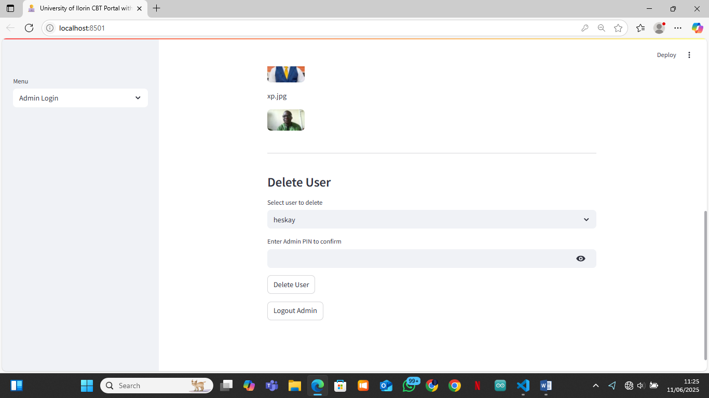Figure 4.5: Admin Dashboard – User Management Tab

D. Time Limits Tab

* + Allows the admin to set and update exam time limits for each user.
  + Ensures fairness and accommodates special needs.

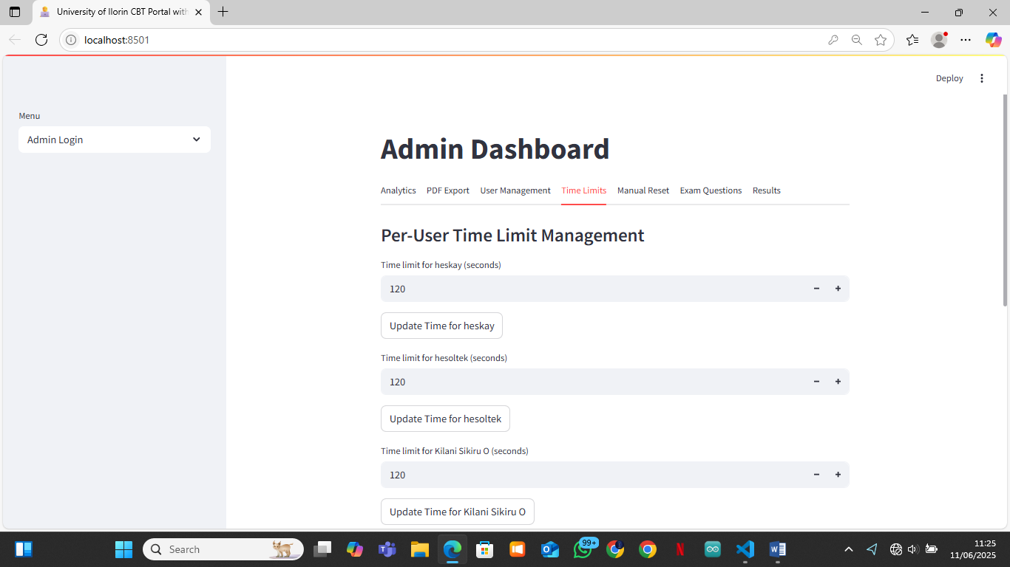Figure 4.6: Admin Dashboard – Time Limits Tab

E. Manual Reset Tab

* + Enables the admin to reset a user’s CBT attempt, allowing for retakes.
  + Useful for handling technical issues or special cases.

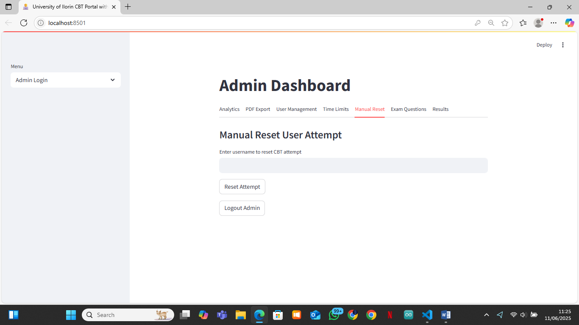Figure 4.7: Admin Dashboard – Manual Reset Tab

F. Exam Questions Tab

* + Provides an interface to add, edit, or delete exam questions.
  + Supports editing options and correct answers for each question.

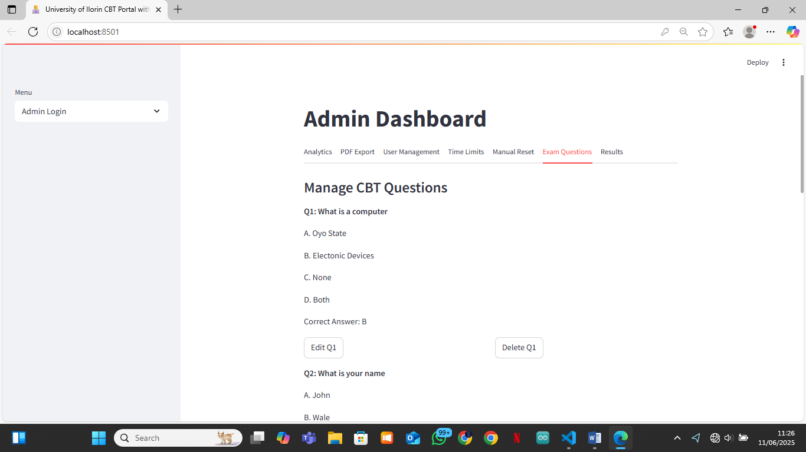Figure 4.8: Admin Dashboard – Exam Questions Tab

G. Results Tab

* + Displays all student results in a table.
  + Allows the admin to generate and download individual student report cards as PDF.

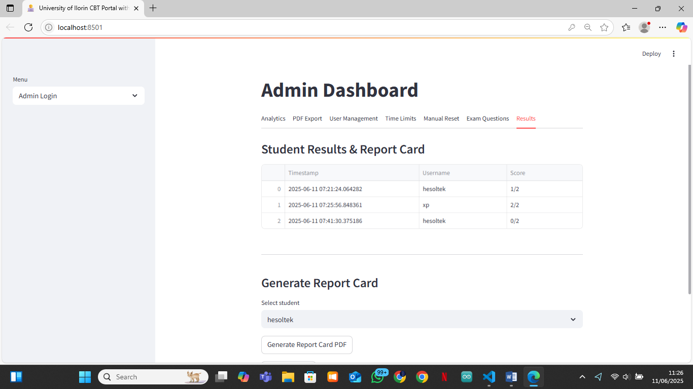

Figure 4.9: Admin Dashboard – Results Tab

4.3.4 User Interface Snapshots

a. Welcome Page

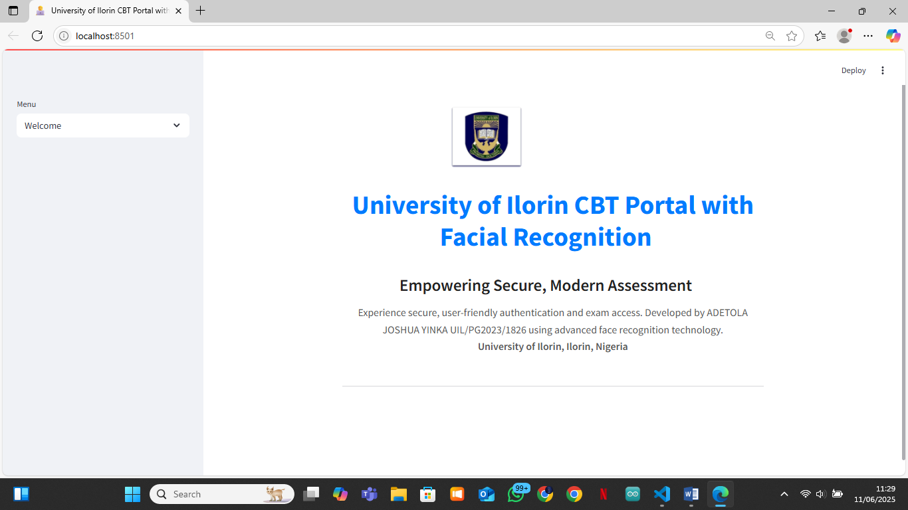Figure 4.10: Welcome Page – University of Ilorin CBT Portal Branding

b. Exam Page

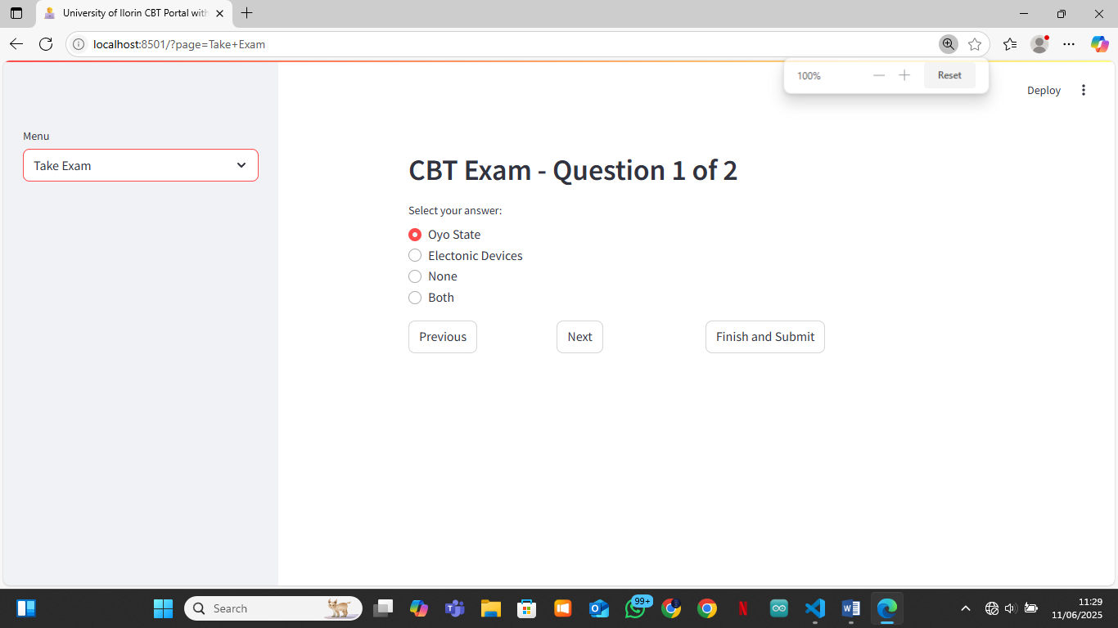

Figure 4.11: Exam Page – One-question-per-page interface

c. Result Page

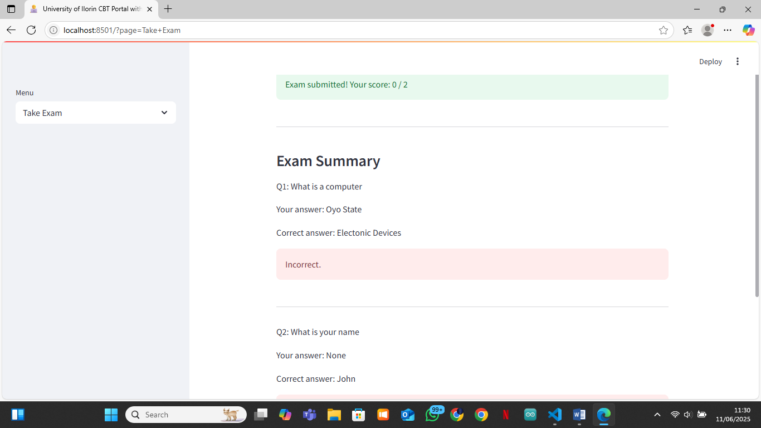

Figure 4.12: Result Page – User’s score and summary

4.4 System Testing and Evaluation

4.4.1 Testing Procedure

Unit Testing: Each module was tested independently for correct functionality.

Integration Testing: Modules were tested together to ensure seamless workflow.

User Acceptance Testing: Real users (students and admin) interacted with the system to validate usability and reliability.

4.4.2 Dataset Description

1. User Images: Real facial images captured via webcam during registration.
2. Exam Questions: Stored in JSON format, covering a range of computer science topics.
3. Results and Logs: Stored in TXT files for analysis and reporting.

4.4.3 Performance Metrics

1. Authentication Accuracy: Measured by the rate of successful and failed logins.
2. Exam Completion Rate: Percentage of users able to complete and submit the exam.
3. Admin Operations: Time and ease of managing users, questions, and results.

4.4.4 Comparative Analysis

1. The facial recognition-based system was compared to traditional password-based CBT systems.
2. Findings: The new system offers higher security, eliminates password fatigue, and reduces impersonation risks.

4.5 Security and Usability Analysis

4.5.1 Security Strength

1. Facial Recognition: Provides strong, biometric-based authentication.
2. Access Control: Only authenticated users can access exams; admin functions are password/PIN protected.
3. Logging: All authentication attempts and results are logged for audit and traceability.

4.5.2 Usability Feedback

1. Students: Reported the system as easy to use, with clear instructions and instant feedback.
2. Admins: Found the dashboard intuitive for managing users, questions, and results.
3. Navigation: One-question-per-page exam format was well received for focus and clarity.

4.6 Discussion of Findings

The system successfully met its objectives:

1. Security: Facial recognition significantly improved exam integrity.
2. Efficiency: Registration, authentication, and exam processes were streamlined.
3. Admin Control: The dashboard provided comprehensive tools for management and reporting.
4. User Experience: Both students and admins reported high satisfaction with the interface and workflow.

4.7 Challenges Encountered

Lighting and Camera Quality: Poor lighting or low-quality webcams affected facial recognition accuracy.

1. User Training: Some users needed guidance for proper face capture.
2. Dependency Management: Ensuring all required Python packages were installed and compatible.
3. File Handling: Managing user images and logs securely and efficiently.

4.8 Summary

This chapter detailed the implementation, testing, and results of the University of Ilorin CBT Portal with Facial Recognition. The system proved to be secure, efficient, and user-friendly, with robust modules for both students and administrators. The findings demonstrate the viability of biometric authentication in academic assessment environments, paving the way for future enhancements and broader adoption.

**CHAPTER FIVE**

**SUMMARY, CONCLUSION AND RECOMMENDATIONS**

**5.1 Summary**

This project focused on the design and implementation of a Computer-Based Test (CBT) Portal for the University of Ilorin, enhanced with facial recognition technology for secure authentication. The system was developed using Python, Streamlit, OpenCV, and FaceNet, and features a modular structure with distinct user and admin interfaces. Key functionalities include webcam-based registration and authentication, a one-question-per-page exam interface, instant result feedback, and a comprehensive admin dashboard for managing users, questions, results, and analytics.

The system was thoroughly tested and evaluated. Results showed that the facial recognition approach significantly improved exam security and user experience compared to traditional password-based systems. The admin dashboard provided robust tools for monitoring, reporting, and managing the entire CBT process.

**5.2 Conclusion**

The University of Ilorin CBT Portal with Facial Recognition successfully addresses the challenges of exam impersonation, user management, and result processing in computer-based assessments. By leveraging biometric authentication, the system ensures that only legitimate users can access and participate in exams. The modular design, intuitive interface, and comprehensive admin controls make the platform suitable for large-scale academic deployment.

The project demonstrates the viability and effectiveness of integrating facial recognition into educational assessment systems, paving the way for more secure and efficient examination processes in academic institutions.

**5.3 Recommendations**

Based on the implementation and evaluation of the system, the following recommendations are made:

1. **Deployment and Scaling:** The system should be deployed on a secure server with adequate resources to handle multiple concurrent users, especially during large-scale examinations.
2. **Continuous User Training:** Users should be educated on proper face capture techniques to ensure high authentication accuracy and reduce false rejections.
3. **Hardware Considerations:** Institutions should provide high-quality webcams and ensure good lighting conditions in exam environments to optimize facial recognition performance.
4. **Integration with Existing Systems:** The portal can be integrated with the university’s student information system for seamless user management and result synchronization.
5. **Regular Updates and Maintenance:** The system should be regularly updated to incorporate the latest security patches, facial recognition models, and feature enhancements.
6. **Further Research:** Future work can explore the integration of additional biometric modalities (e.g., fingerprint, voice) and advanced anti-spoofing techniques to further enhance security.

**5.4 Limitations**

1. The system’s accuracy is affected by camera quality and environmental lighting.
2. Users unfamiliar with webcam technology may require assistance.
3. The current implementation relies on local file storage; migrating to a database would improve scalability and data management.

**5.5 Suggestions for Future Work**

1. Implement mobile device support for greater accessibility.
2. Add real-time proctoring features to monitor exam sessions.
3. Develop a more advanced analytics dashboard for deeper insights into exam performance and user behavior.
4. Integrate with cloud-based storage and authentication services for enhanced reliability and scalability.

**5.6 Closing Remark**

The successful implementation of the University of Ilorin CBT Portal with Facial Recognition marks a significant step towards secure, efficient, and modern academic assessment. With continued development and adoption, such systems can transform the landscape of educational testing in Nigeria and beyond.